Circuit Analysis (Lab # 6)
Experiment 6: VERIFICATION OF KIRCHHOFFS LAWS

Objective
To verify Kirchhoff’s current law and Kirchhoff’s voltage law for the given Circuit.
Apparatus Required
Sr. no | Apparatus | Range | Quantity
1 | Regulated Power Supply | Standard | 1
2 | Signal Generator | Standard | 1
3 | Oscilloscope | Standard | 1
4 | Digital Multimeter | Standard | 1
5 | Breadboard & Wires | Standard | As Required
6 | Resistors | 330ohm, 220ohm 1kohm | 3
Description
KCL: The algebraic sum of the currents meeting at a node is equal to zero.
KVL: In any closed path / mesh, the algebraic sum of all the voltages is zero.
Precautions:
- Voltage control knob should be kept at minimum position.
- Current control knob of RPS should be kept at maximum position.

Procedure for KCL:
- Give the connections as per the circuit diagram.
- Set a value in RPS.
- Note down the corresponding readings using multimeter
- Repeat the same for different voltages
Circuit - KCL

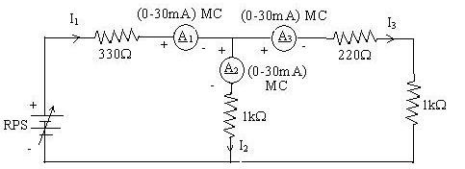

KCL - Practical Values:

Sl. No. | Voltage E |  | Current |  | I1 = I2 + I3
 |  | I1 | I2 | I3
 | Volts | mA | mA | mA | mA
1 | 5 | 9.8 | 8.05 | 1.77 | 9.82
2 | 15 | 29.4 | 24.1 | 5.31 | 29.4
3 | 25 | 49.0 | 40.2 | 8.85 | 49.0

Procedure for KVL:
- Give the connections as per the circuit diagram.
- Set a value in RPS.
- Note all the voltage reading
- Repeat the same for different voltages

Circuit - KVL

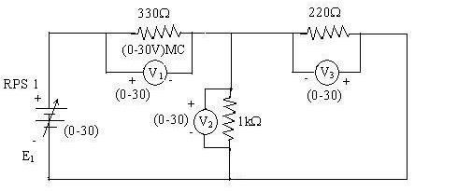

KVL - Practical Values

Sl. No. | RPS |  | Voltage |  | E1 = V1 + V2
 | E1 | V1 | V2 | V3
 | V | V | V | V | V
1 | 5 | 1.06 | 3.23 | 0.71 | 5.0
2 | 10 | 2.13 | 6.45 | 1.42 | 10.0
3 | 15 | 3.19 | 9.68 | 2.13 | 15.0

Result:
Thus, Kirchhoff’s voltage law and Kirchhoff’s current law are verified practically by performing this experiment.

Post Lab Questions

- Define Kirchhoff’s current law.
Kirchhoff’s Current Law (KCL) states that the sum of currents entering a node equals the sum of currents leaving it. In other words, the algebraic sum of currents at a junction is always zero.
- Define Kirchhoff’s voltage law.
Kirchhoff’s Voltage Law (KVL) says that if you walk around any closed loop in a circuit, the total voltage you gain and lose will always balance out to zero. Simply put, the energy supplied by sources is exactly used up by the components in that loop.

- What are the applications of regulated power supply?
A regulated power supply is mainly used to deliver a stable DC voltage to electronic circuits. It is widely applied in laboratories, communication systems, medical devices, and control equipment, where precise voltage is essential. By preventing fluctuations and surges, it protects sensitive components and ensures reliable performance.
- What are the limitations of KCL?
The main limitations of Kirchhoff’s Current Law (KCL) are:
- It assumes that the circuit is lumped (no distributed parameters like transmission lines).
- It does not account for parasitic elements such as stray capacitance or inductance.
- It is valid only when the circuit obeys the principle of charge conservation and there is no accumulation of charge at a node.
In short, KCL may not hold perfectly in high-frequency or non-ideal circuits where these effects become significant.

-------------------------------------------------------------------------------------

